**Linux commands – cheat sheet**

***SEARCH:***

grep ‘pattern’ files => Search for a given pattern in files

grep -r pattern dir => Search recursively for a pattern in a given directory

locate file => Find all instances of the file

find /home/ -name “index” => Find file names that begin with ‘index’ in /home folder

find /home –size + 10000k => Find files greater than 10000k in the home folder

***SYSTEM:***

uname => Displays Linux system information

uname -r => Displays kernel release information

uptime => Displays how long the system has been running including load average

hostname => Shows the system hostname

hostname -i => Displays the IP address of the system

last reboot => Shows system reboot history

date => Displays current system date and time

timedatectl => Query and change the System clock

cal => Displays the current calendar month and day

w => Displays currently logged in users in the system

whoami => Displays who you are logged in as

finger username => Displays information about the user

***HARDWARE:***

dmesg => Displays bootup messages

cat /proc/cpuinfo => Displays more information about CPU e.g model, model name, cores, vendor id

cat /proc/meminfo => Displays more information about hardware memory e.g. Total and Free memory

lshw => Displays information about system’s hardware configuration

lsblk => Displays block devices related information

free -m => Displays free and used memory in the system (-m flag indicates memory in MB)

lspci -tv => Displays PCI devices in a tree-like diagram

lsusb -tv => Displays USB devices in a tree-like diagram

dmidecode => Displays hardware information from the BIOS

hdparm -i /dev/xda => Displays information about disk data

hdparm -tT /dev/xda => Conducts a read speed test on device xda

badblocks -s /dev/xda => Tests for unreadable blocks on disk

***USERS:***

id => Displays the details of the active user e.g. uid, gid, and groups

last => Shows the last logins in the system

who => Shows who is logged in to the system

groupadd “admin” => Adds the group ‘admin’

adduser “Sam” => Adds user Sam

userdel “Sam” => Deletes user Sam

usermod => Used for changing / modifying user information

***FILE COMMANDS:***

ls -al => Lists files - both regular & hidden files and their permissions as well.

pwd => Displays the current directory file path

mkdir ‘directory\_name’ => Creates a new directory

rm file\_name => Removes a file

rm -f filename => Forcefully removes a file

rm -r directory\_name => Removes a directory recursively

rm -rf directory\_name => Removes a directory forcefully and recursively

cp file1 file2 => Copies the contents of file1 to file2

cp -r dir1 dir2 => Recursively Copies dir1 to dir2. dir2 is created if it does not exist

mv file1 file2 => Renames file1 to file2

ln -s /path/to/filename linkname => Creates a symbolic link to filename

touch file\_name => Creates a new file

cat > file\_name => Places standard input into a file

more file\_name => Outputs the contents of a file

head file\_name => Displays the first 10 lines of a file

tail file\_name => Displays the last 10 lines of a file

gpg -c file\_name => Encrypts a file

gpg file\_name.gpg => Decrypts a file

wc => Prints the number of bytes, words and lines in a file

xargs => Executes commands from standard input

***PROCESS RELATED:***

ps => Display currently active processes

ps aux | grep ‘telnet’ => Searches for the id of the process ‘telnet’

pmap => Displays memory map of processes

top => Displays all running processes

kill pid => Terminates process with a given pid

killall proc => Kills / Terminates all processes named proc

pkill process-name => Sends a signal to a process with its name

bg => Resumes suspended jobs in the background

fg => Brings suspended jobs to the foreground

fg n => Brings job n to the foreground

lsof => Lists files that are open by processes

renice 19 PID => Makes a process run with very low priority

pgrep firefox => Find Firefox process ID

pstree => Visualizing processes in tree model

***FILE PERMISSION:***

chmod octal filename => Change file permissions of the file to octal

**Example**

chmod 777 /data/test.c => Set rwx permissions to owner, group and everyone (everyone else who has access to the server)

chmod 755 /data/test.c => Set rwx to the owner and r\_x to group and everyone

chmod 766 /data/test.c => Sets rwx for owner, rw for group and everyone

chown owner user-file => Change ownership of the file

chown owner-user: owner-group file\_name => Change owner and group owner of the file

chown owner-user:owner-group-directory => Change owner and group owner of the directory

***NETWORK:***

ip addr show => Displays IP addresses and all the network interfaces

ip address add 192.168.0.1/24 dev eth0 => Assigns IP address 192.168.0.1 to interface eth0

ifconfig => Displays IP addresses of all network interfaces

ping host => ping command sends an ICMP echo request to establish a

connection to server / PC

whois domain => Retrieves more information about a domain name

dig domain => Retrieves DNS information about the domain

dig -x host => Performs reverse lookup on a domain

host google.com => Performs an IP lookup for the domain name

hostname -i => Displays local IP address

wget file\_name => Downloads a file from an online source

netstat -pnltu => Displays all active listening ports

***COMPRESSION/ARCHIVES:***

tar -cf home.tar home => Creates archive file called ‘home.tar’ from file ‘home’

tar -xf files.tar => Extract archive file ‘files.tar’

tar -zcvf [home.tar.gz](http://home.tar.gz) => Creates gzipped tar archive file from source folder

gzip file => Compression a file with .gz extension

***INSTALL SOURCE (complilation):***

./configure

make

make install

***LOGIN:***

ssh user@host => Securely connect to host as user

ssh -p port\_number user@host => Securely connect to host using a specified port

ssh host => Securely connect to the system via SSH default port 22

telnet host => Connect to host via telnet default port 23

***FILE TRANSFER:***

scp file1.txt server2/tmp => Securely copy file1.txt to server2 in /tmp directory

rsync -a /home/apps /backup/ => Synchronize contents in /home/apps directory with /backup directory

***DIRECTORY TRAVERSE:***

cd .. => Move up one level in the directory tree structure

cd => Change directory to $HOME directory

cd /test => Change directory to /test directory

***DISK USAGE:***

df -h => Displays free space on mounted systems

df -i => Displays free inodes on filesystems

fdisk –l => Shows disk partitions, sizes, and types

du -sh => Displays disk usage in the current directory in a human-readable format

findmnt => Displays target mount point for all filesystems

mount device-path mount-point => Mount a device

***INSTALL PACKAGES:***

rpm -i pkg\_name.rpm => Install an rpm package

rpm -e pkg\_name => Removes an rpm package

dnf install pkg\_name => Install package using dnf utility

sudo !! => Running the command without specifying sudo command will give you permission denied error. So, you don’t

need to rewrite the whole command again just put ‘!!‘ will grab the last command.

# python –m SimpleHTTPServer

The below command generates a simple web page over HTTP for the directory structure tree and can be accessed at port 8000 in browser till interrupt signal is sent.

[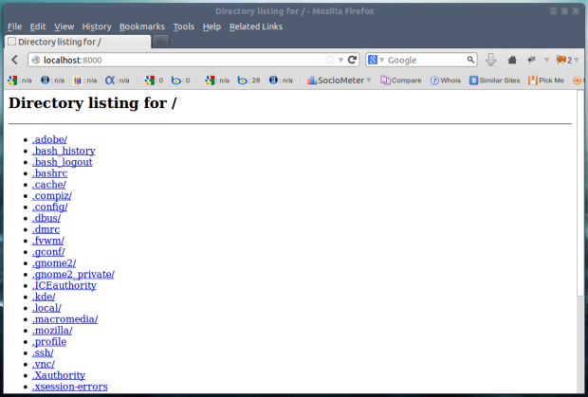](https://www.tecmint.com/wp-content/uploads/2013/10/Python-m.png)

# mtr google.com

Most of us are familiar with ping and traceroute. How about combining the functionality of both the command into one with mtr command. In case mtr is not installed into your machine, apt or yum the required package.

$ sudo apt-get install mtr

[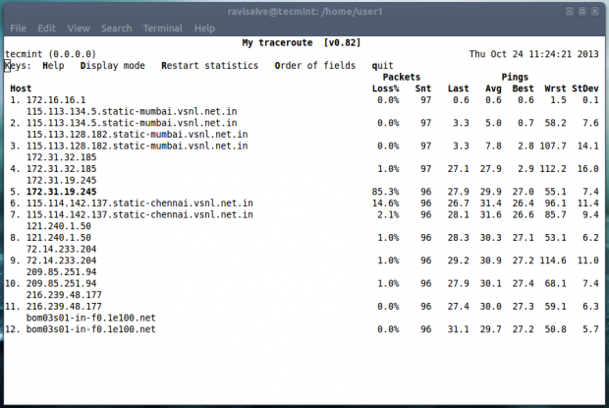](https://www.tecmint.com/wp-content/uploads/2013/10/mtr-command.png)

# ss

The “ss” stands for socket statistics. The command investigates the socket and shows information similar to [netstat command](https://www.tecmint.com/20-netstat-commands-for-linux-network-management/" \t "_blank). It can display more TCP and state informations than other tools.

# curl ifconfig.me

So how do you obtain your External IP address? Using google?. Well the command output your external IP address right into your terminal.

# tree

Get the current directory structure in tree like format.

# pstree

This commands shows all the processes running currently along with associated child process, in a tree like format similar to ‘tree‘ command output.